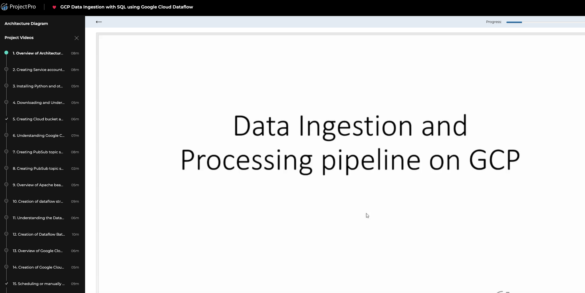

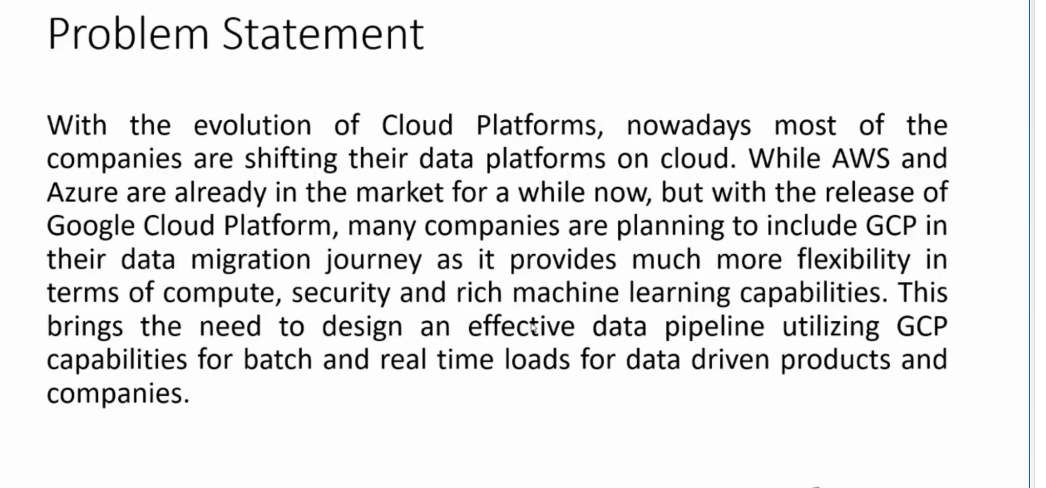

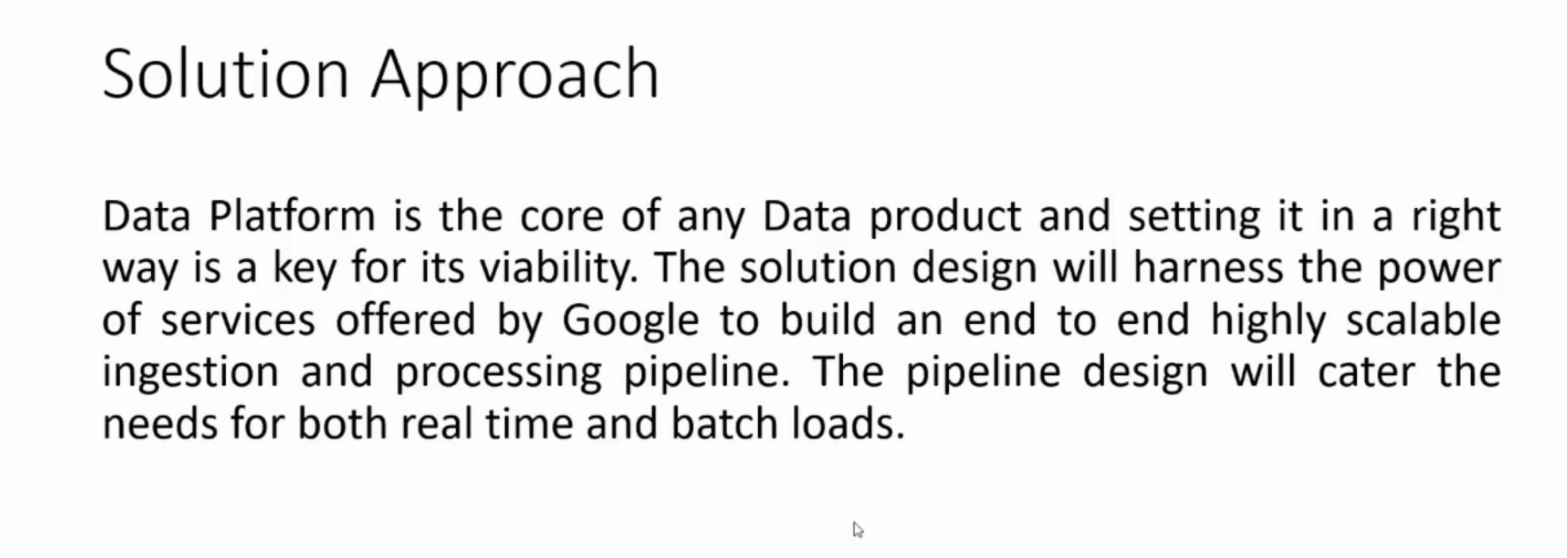

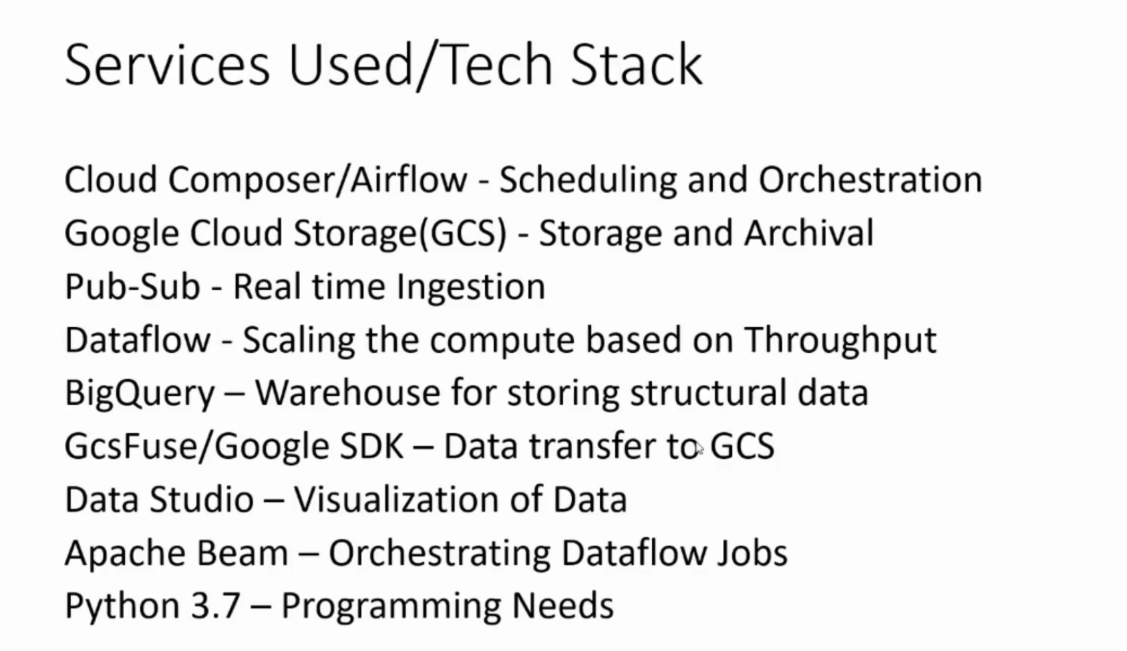

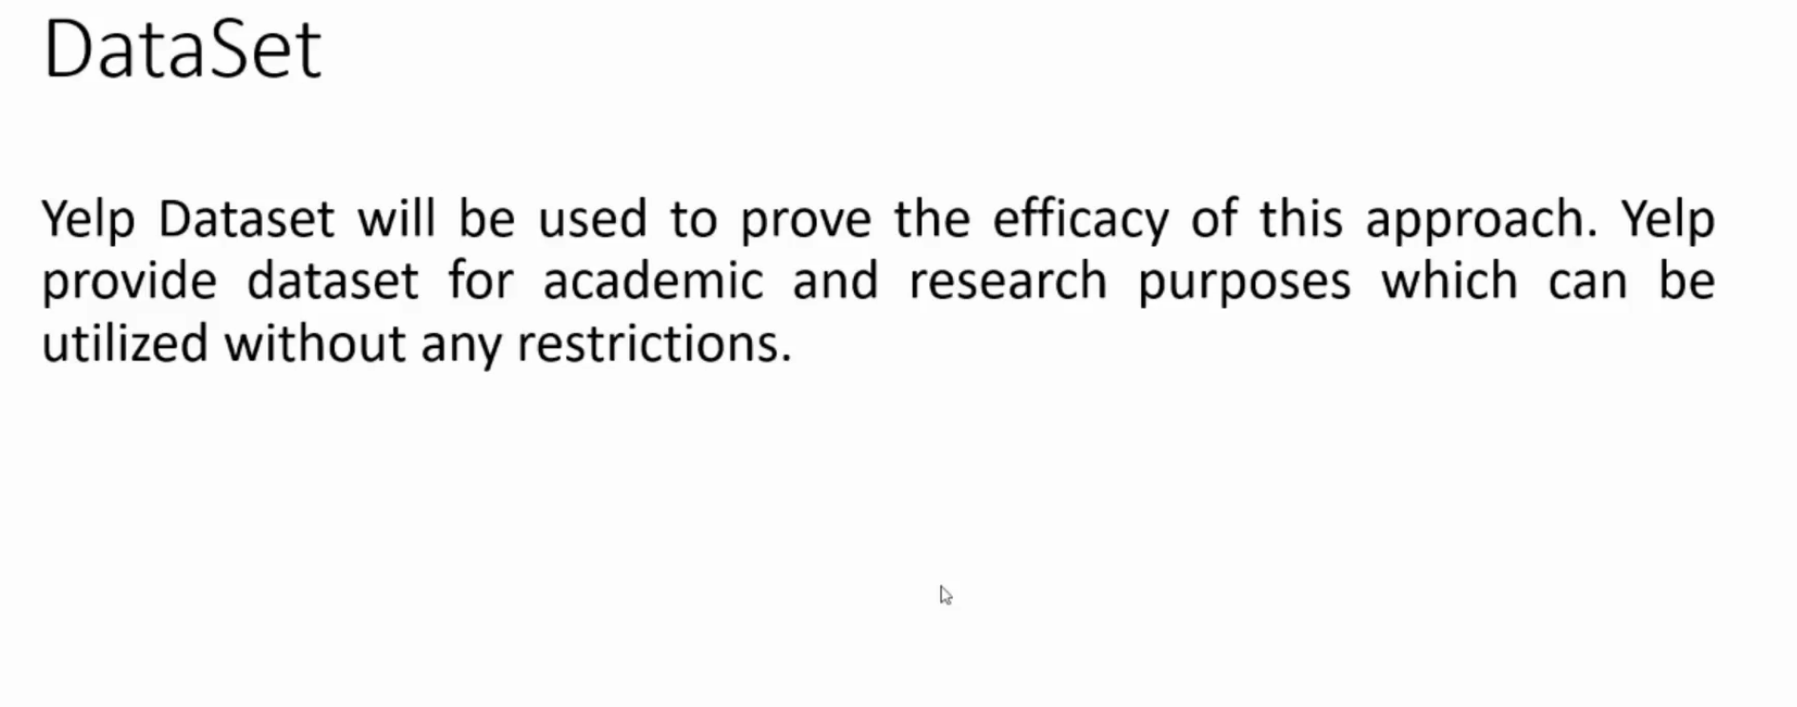

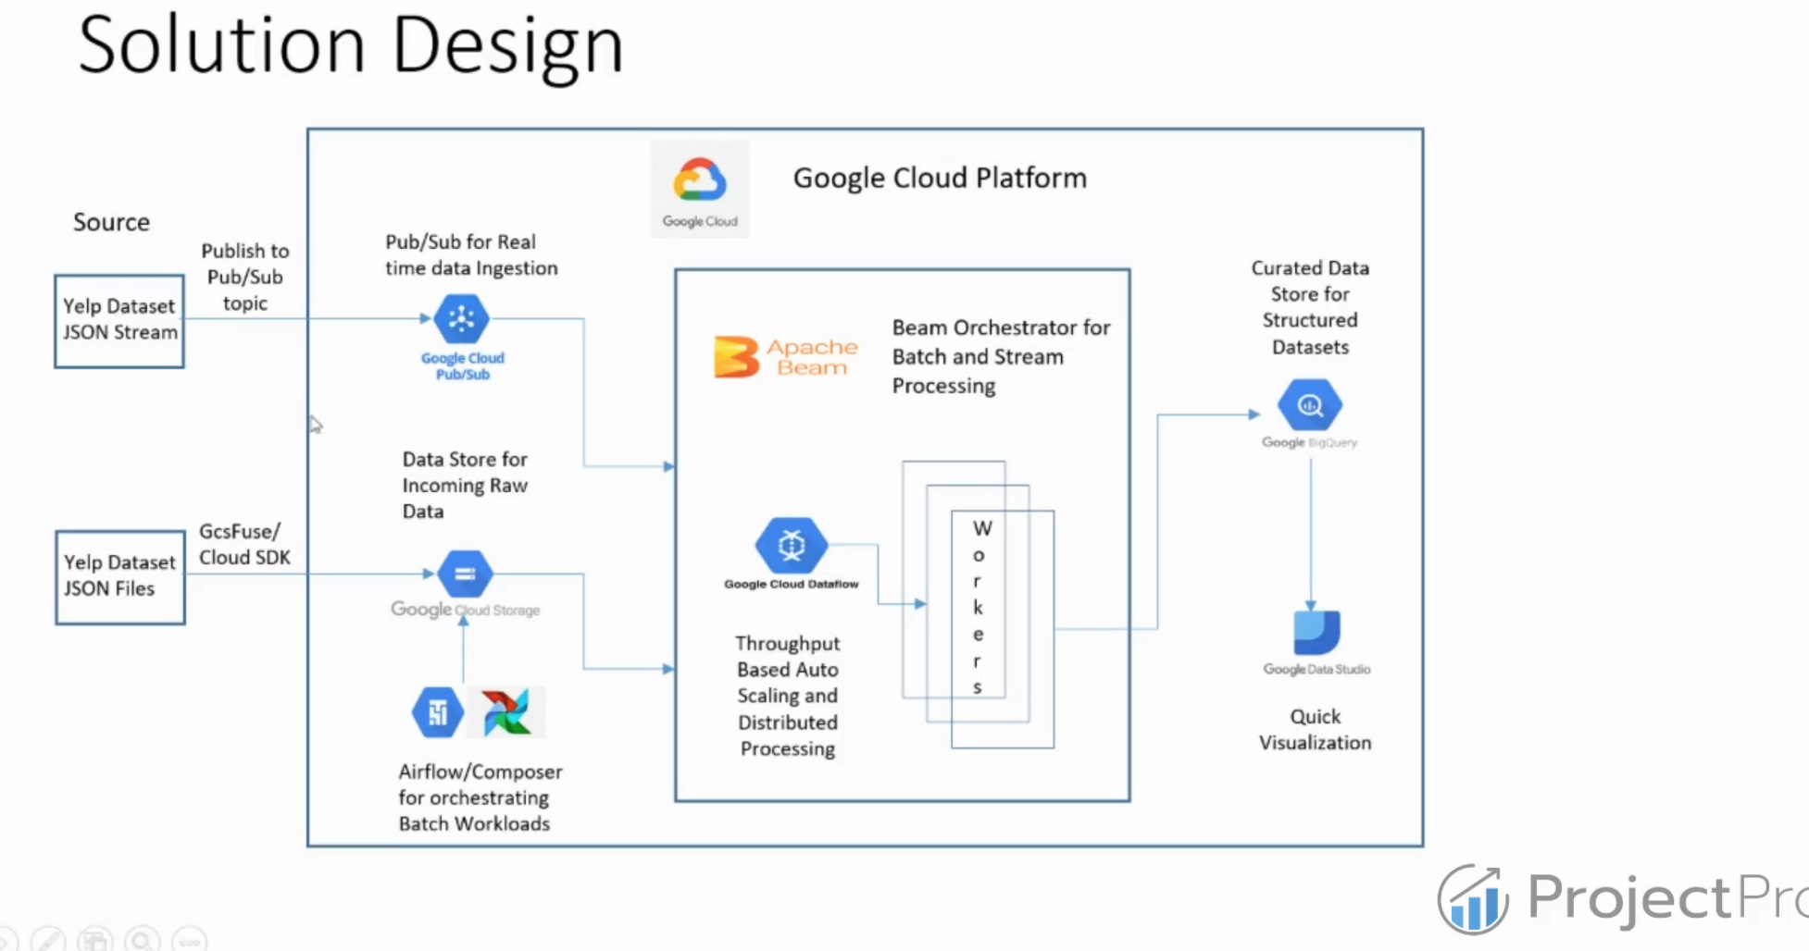

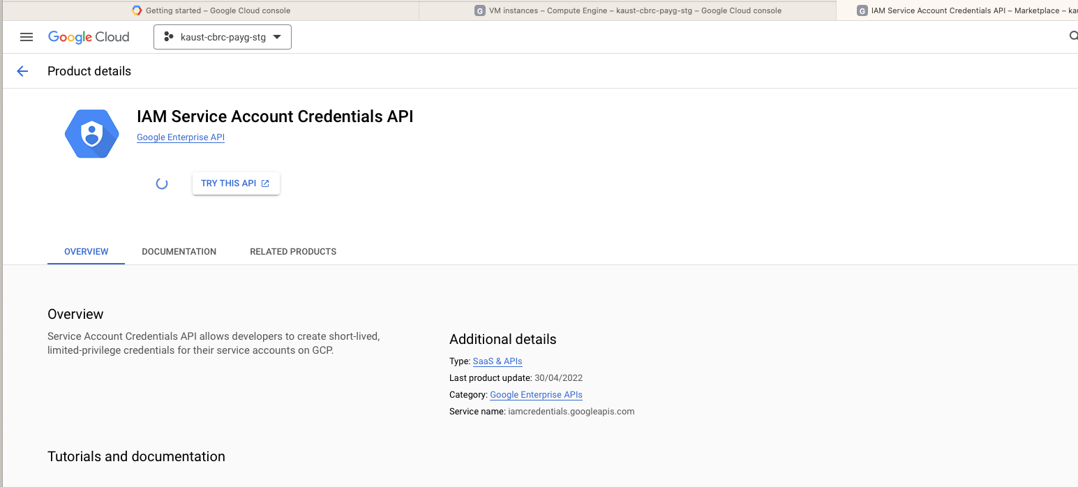

gcloud auth activate-service-account svc2-rw@kaust-cbrc-payg-stg.iam.gserviceaccount.com --key-file=/Users/admin/Downloads/service_account.json --project=kaust-cbrc-payg-stg

$ gcloud init

Welcome! This command will take you through the configuration of gcloud.

Settings from your current configuration [default] are:

core:

account: svc2-183@pi-xin.iam.gserviceaccount.com

disable_usage_reporting: 'True'

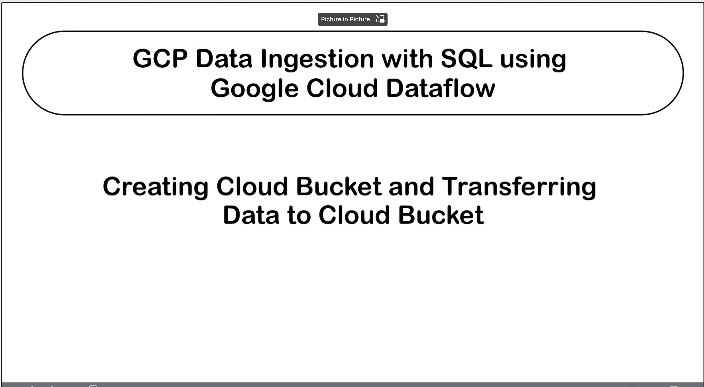



**Gsutil -m cp *.json (copies files in multiple thread)**

(gcp_myenv) **saifm@kw60405**:**~**$ cat gcp_enviornment.yml

name: gcp_myenv

channels:

- defaults

dependencies:

- python=3.7

- pip

- pip:

- apache-beam[gcp]

# Add any other packages you want to install. For example:

# - numpy

# - pandas

conda env update -f gcp_enviornment.yml

gsutil -m cp *.json gs://gcs-bigpro-bucket/

Copying file://yelp_academic_dataset_business.json [Content-Type=application/json]...

Copying file://yelp_academic_dataset_checkin.json [Content-Type=application/json]...

Copying file://yelp_academic_dataset_review.json [Content-Type=application/json]...

==> NOTE: You are uploading one or more large file(s), which would run

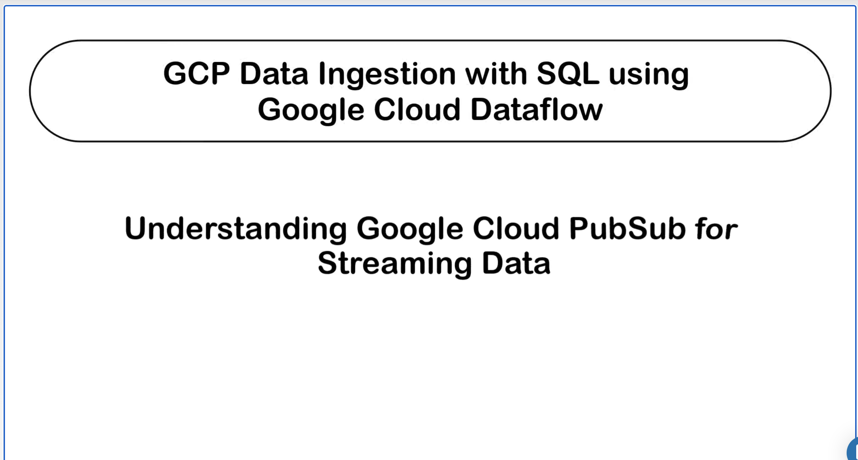

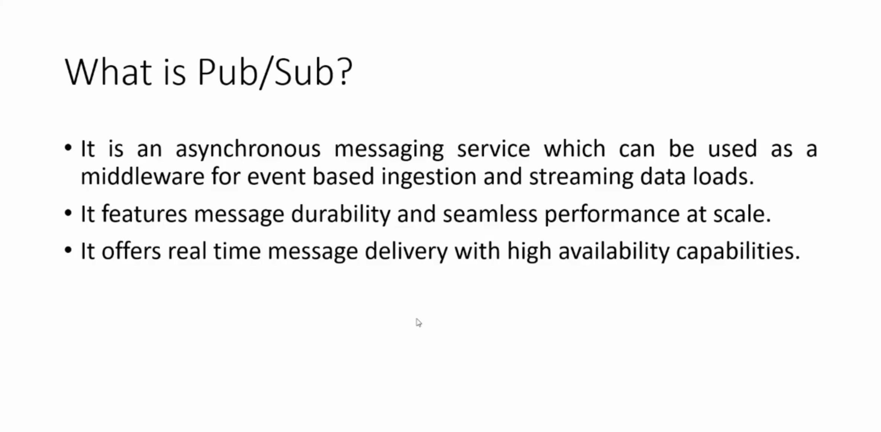

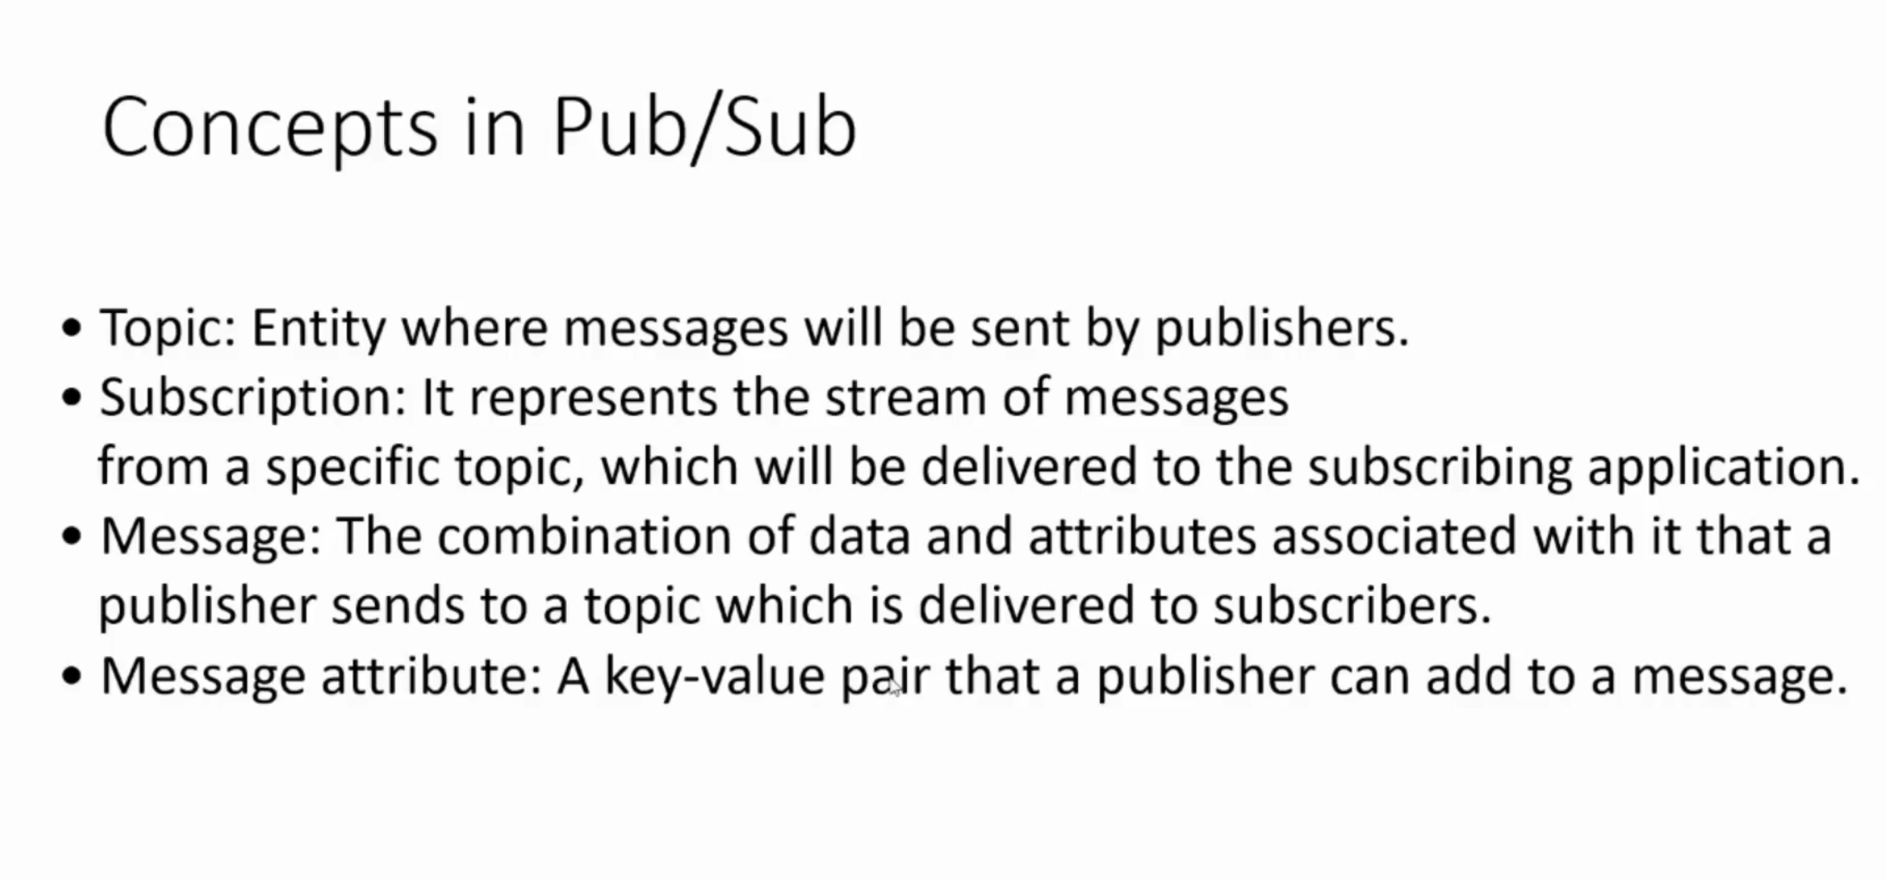

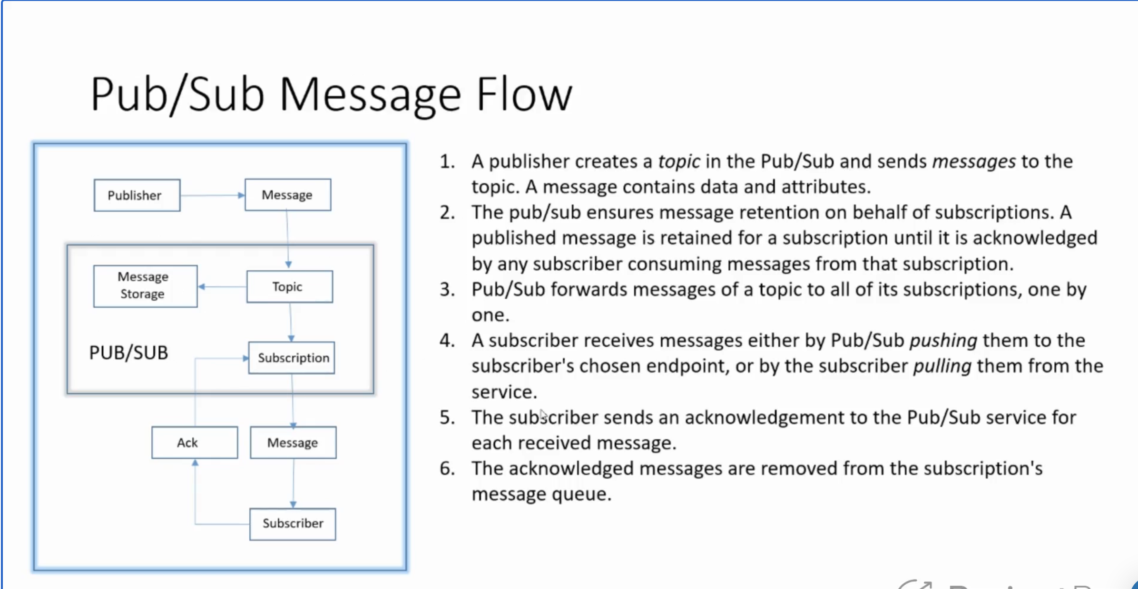

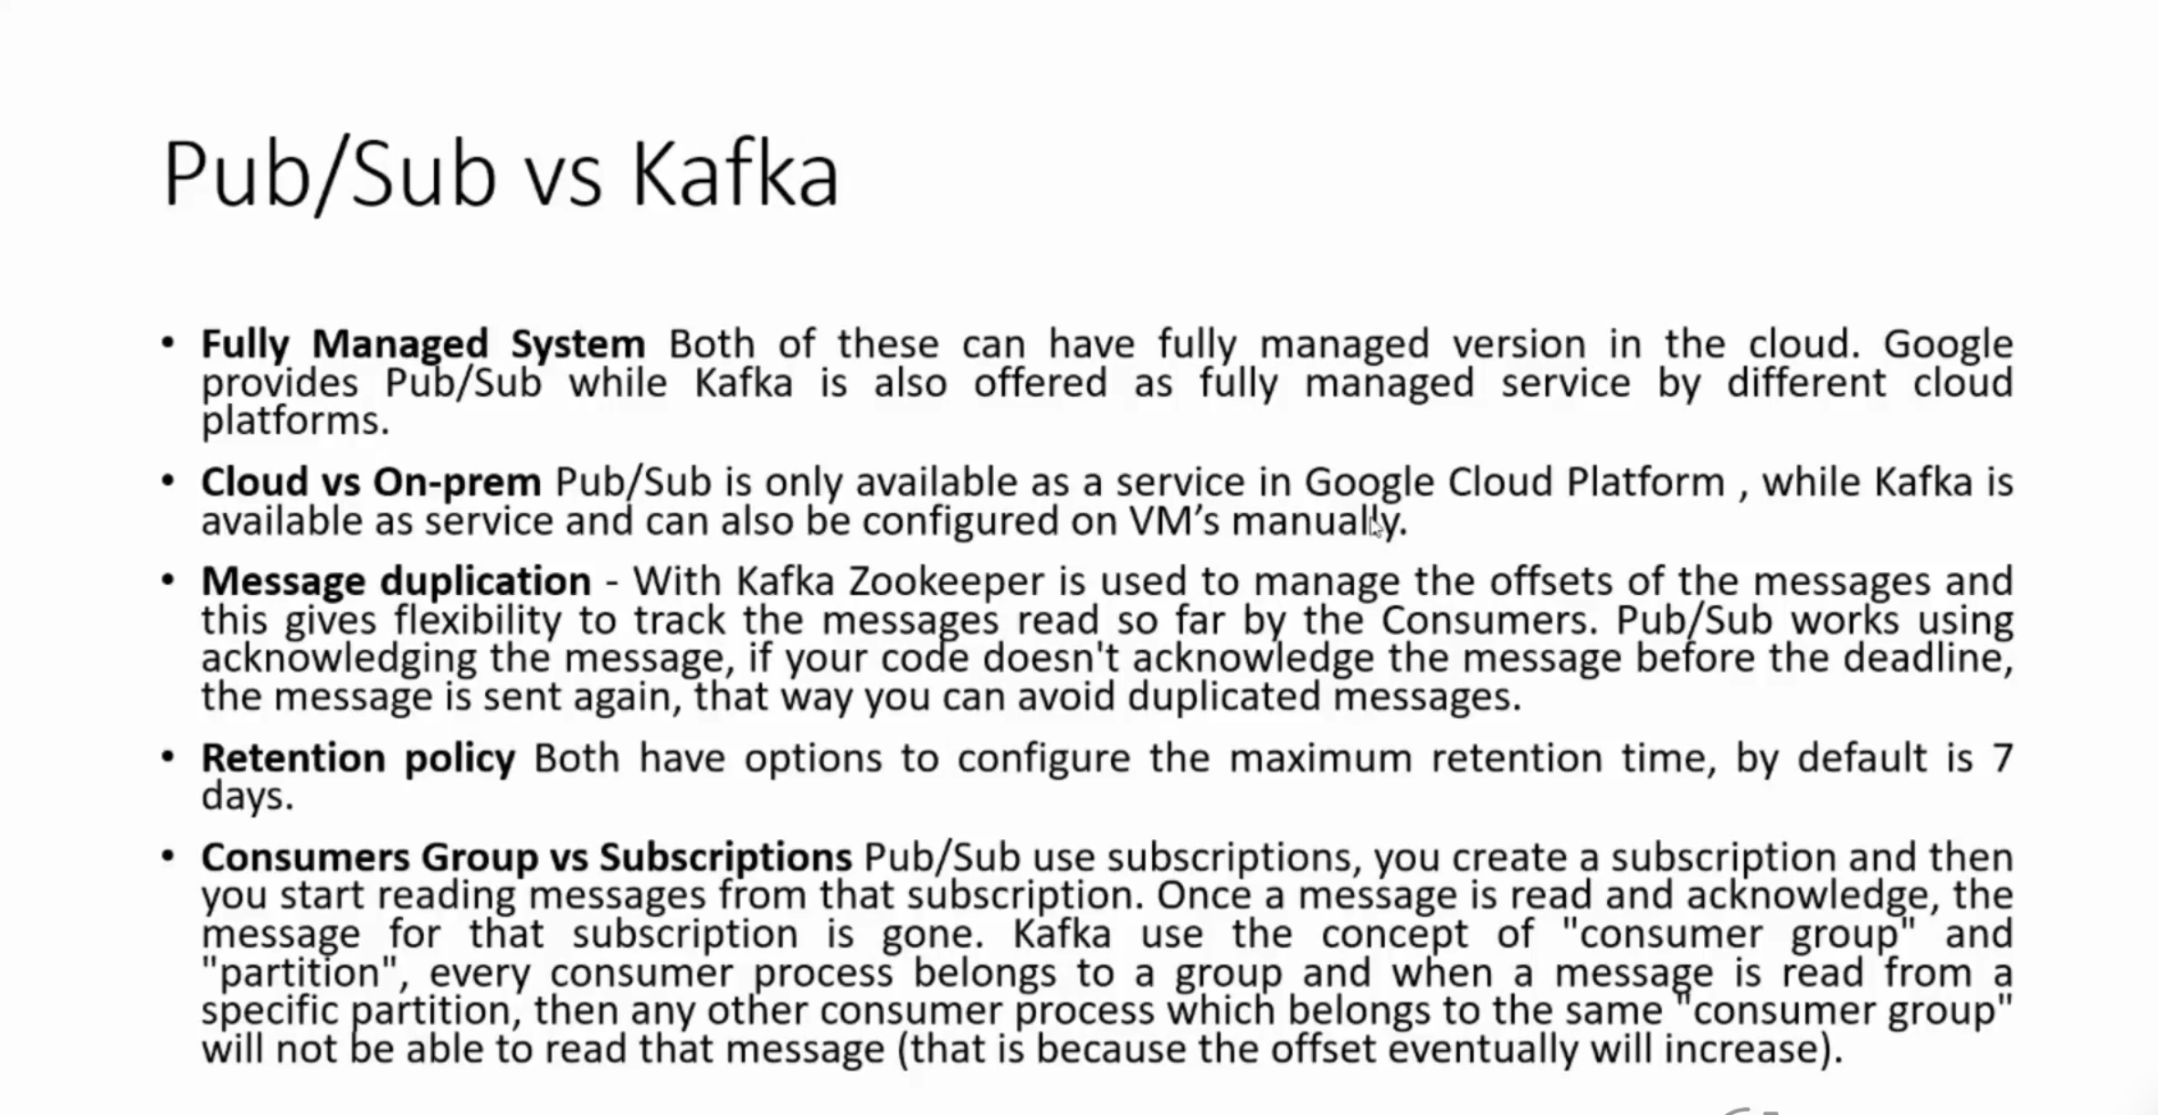

python3.7 yelp_dataset/Data-Ingestion-ProcessinPipeline-GCP/Codes/Python/publish_messages.py --config_path=yelp_dataset/Data-Ingestion-ProcessinPipeline-GCP/Codes/Database/publish_config.ini

